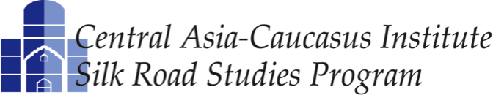

A Joint Transatlantic Research and Policy Center

RUMSFELD FELLOWS SPRING 2015

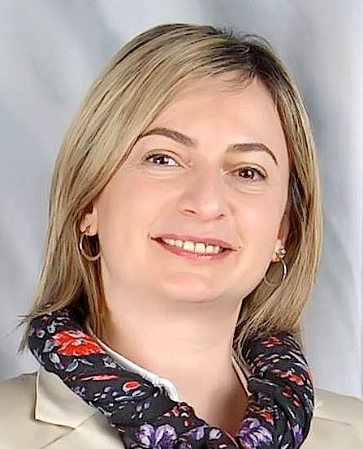
Ms. Zara Chatinyan (Armenia), 39, is the Local Representative of German Development Bank (KfW) in Armenia. KfW has a more than 600 million euro investment portfolio in Armenia’s energy, drinking water and irrigation, and banking and agriculture sectors, accompanied by significant technical assistance in legislative reforms. Ms. Chatinyan works closely with the governments of Armenia and Germany to identify sectors for reforms and targeted infrastructure projects, facilitates intergovernmental negotiations, participates in multi-million sovereign loan negotiations and project preparations, supports the introduction of international standards in project management and implementation, and is also in charge of cooperation with international financial institutions such as the IMF, World Bank, ADB, EBRD, etc. Ms. Chatinyan has more than ten years of experience in USAID financed projects in decentralization, policy and institutional development, strategic planning and municipal service improvements. Ms. Chatinyan holds a B.A. in Philology from the Teachers’ Training Institute in Armenia (1998), a Master of Public Administration degree from the University of Delaware (2000) as a recipient of the prestigious Muskie Fellowship, and a Certificate in Executive Management and Leadership from the Judge Institute of Management at the University of Cambridge (2003). Research Project: "Toward Integration or Isolation: Western Values and Free Trade vs. National Security in Armenia."

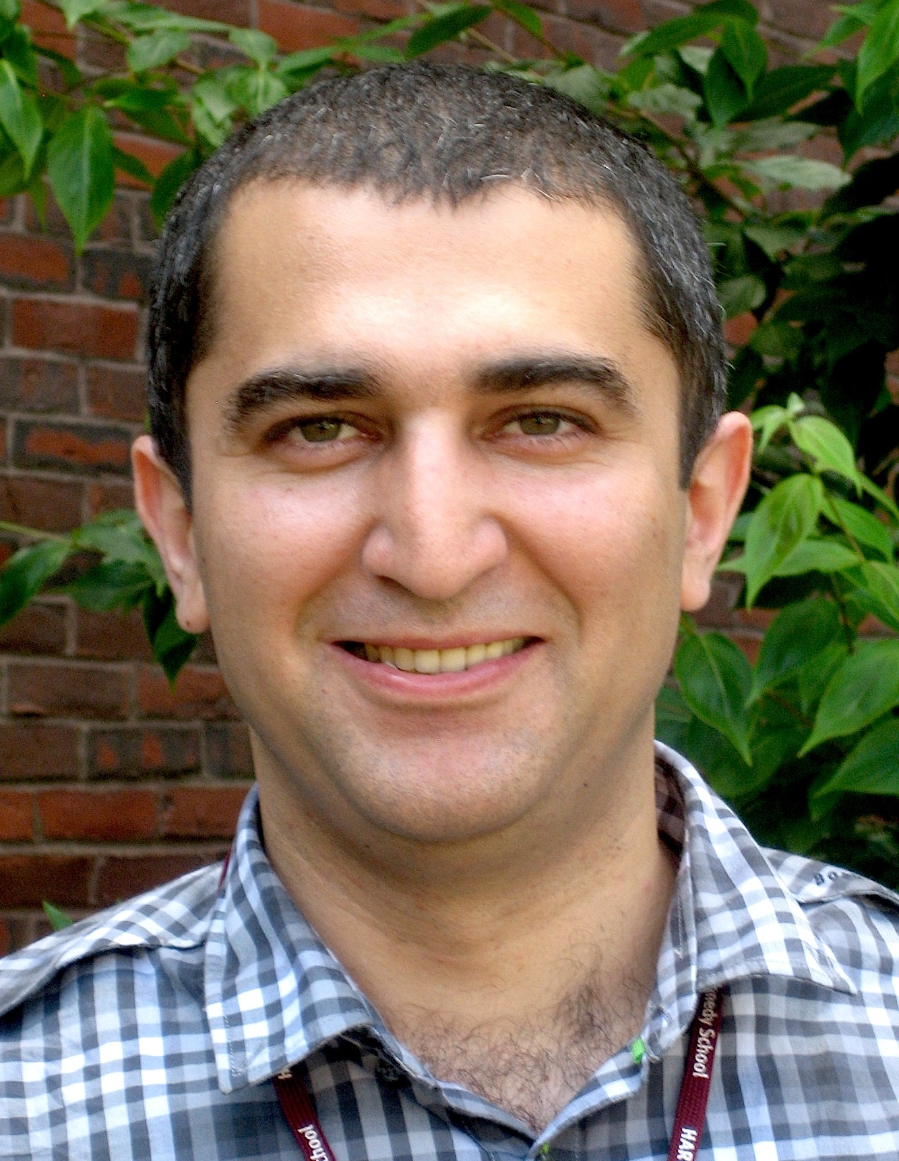
Mr. Anar Jahangirli (Azerbaijan), 36, is the Vice President for Corporate Affairs at the AzMeCo Group of Companies. Mr. Jahangirli’s experience since 2011 as a private entrepreneur also includes working in senior positions as an Adviser to the CEO at the Azerbaijan Consulting Group, and as the Director for Corporate Communications at Azercell Telecom. He has also established several of his own companies. Prior to moving to the private sector, Mr. Jahangirli worked for more than a decade at the Azerbaijan Foreign Service including a tour in the Mission of Azerbaijan to the EU in Brussels. Mr. Jahangirli holds a B.A. in International Relations and International Law from Baku State University (1999), a M.A. in European Public Affairs from the University of Maastricht, the Netherlands (2001), and a M.P.A. from the Kennedy School of Government at Harvard University (2011). He has also completed courses in the Diplomatic Academy in Vienna, Austria and NATO Defense College in Rome, Italy. Research project: "Transformation to a Knowledge-based Economy: The Case of Azerbaijan."

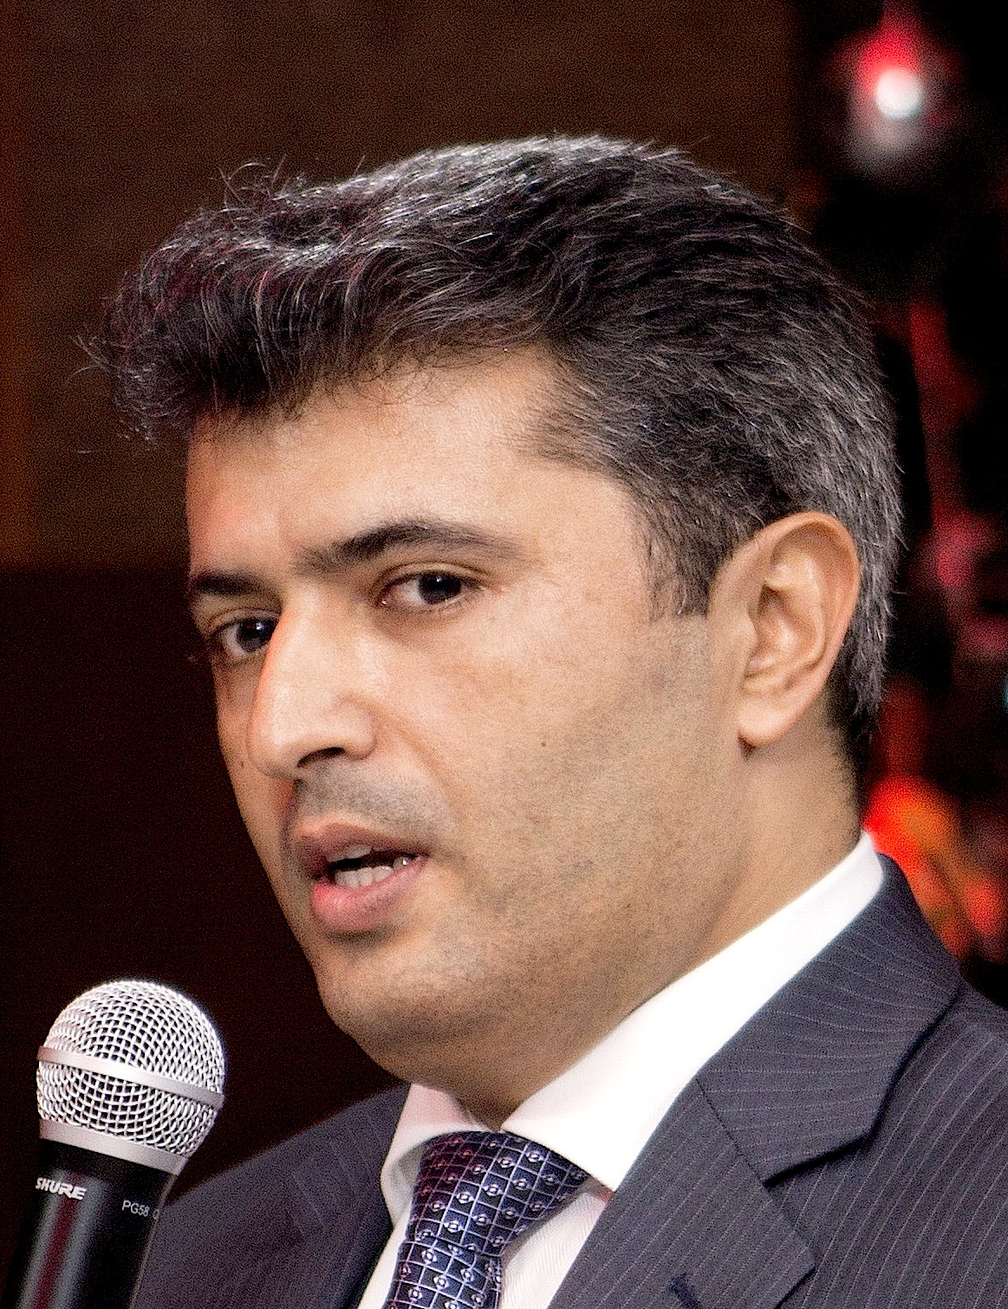
Mr. Ilgar Taghiyev (Azerbaijan), 34, is the Chief Executive Officer at EMBAFINANS, one of the largest non-bank credit organizations based in Baku, Azerbaijan, that extends microloans to retail consumers. EMBAFINANS opened in 2012 and in three years expanded its service network to 135 points of sales with $45 million in assets. Mr. Taghiyev has more than 17 years of experience in the banking industry with a focus on micro-lending. Prior to joining EMBAFINANS, he was a Deputy CEO of Qafqaz Leasing, which primarily served SMEs and was the first company in Azerbaijan to provide micro-leasing products. From 2009-2011 Mr. Taghiyev was a Senior Consultant for EBRD’s project on SME lending and co-financing. He has served in various senior positions at Demir Bank (formerly Azerdemiryolbank) and Bank of Baku. Mr. Taghiyev holds a B.A. in Finance and Banking from Azerbaijan State Economics University (2001) and is currently pursuing a joint Executive M.B.A. degree at Maastricht School of Management and ADA University. He was also a MasterCard Foundation Scholar in Microfinance at the Summer Academy of Frankfurt School of Finance and Management and received certification as an Expert in Microfinance (2012). Research project: "Fluctuations in Money and FX Market."

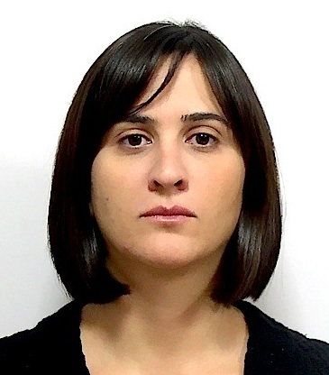
Ms. Nino Evgenidze (Georgia), 39, is the Executive Director at the Economic Policy Research Center (EPRC) in Tbilisi, Georgia, which she joined in 2004. At the same time, Mr. Evgenidze is an anchor of a morning economic show at the Radio Free Europe/Radio Liberty, and a member of the Anticorruption Policy Coordination Council of Georgia. Prior to joining EPRC, Ms. Evgenidze served in various positions in the Government of Georgia, non-governmental sector and international organizations. She holds a B.A. and a M.A. in World Culture and Literature from Tbilisi State University (1997), a Ph.D. in Philosophy from the same University (2002), and a M.A. in Economic Policy Management from the London School of Economics, UK, as a Chevening Fellow (2005). She also graduated from the Department of Economic Policy Administration of the Joint Vienna Institute in Vienna, Austria with the World Bank Scholarship (2000), has a diploma in Management of International Projects from University of Maastricht in the Netherlands as a Nuffic Fellow (2010) and was a Draper Hills Summer Fellow at the Center on Democracy, Development, and the Rule of Law at Stanford University (2013). Research project: "Economic NATO."

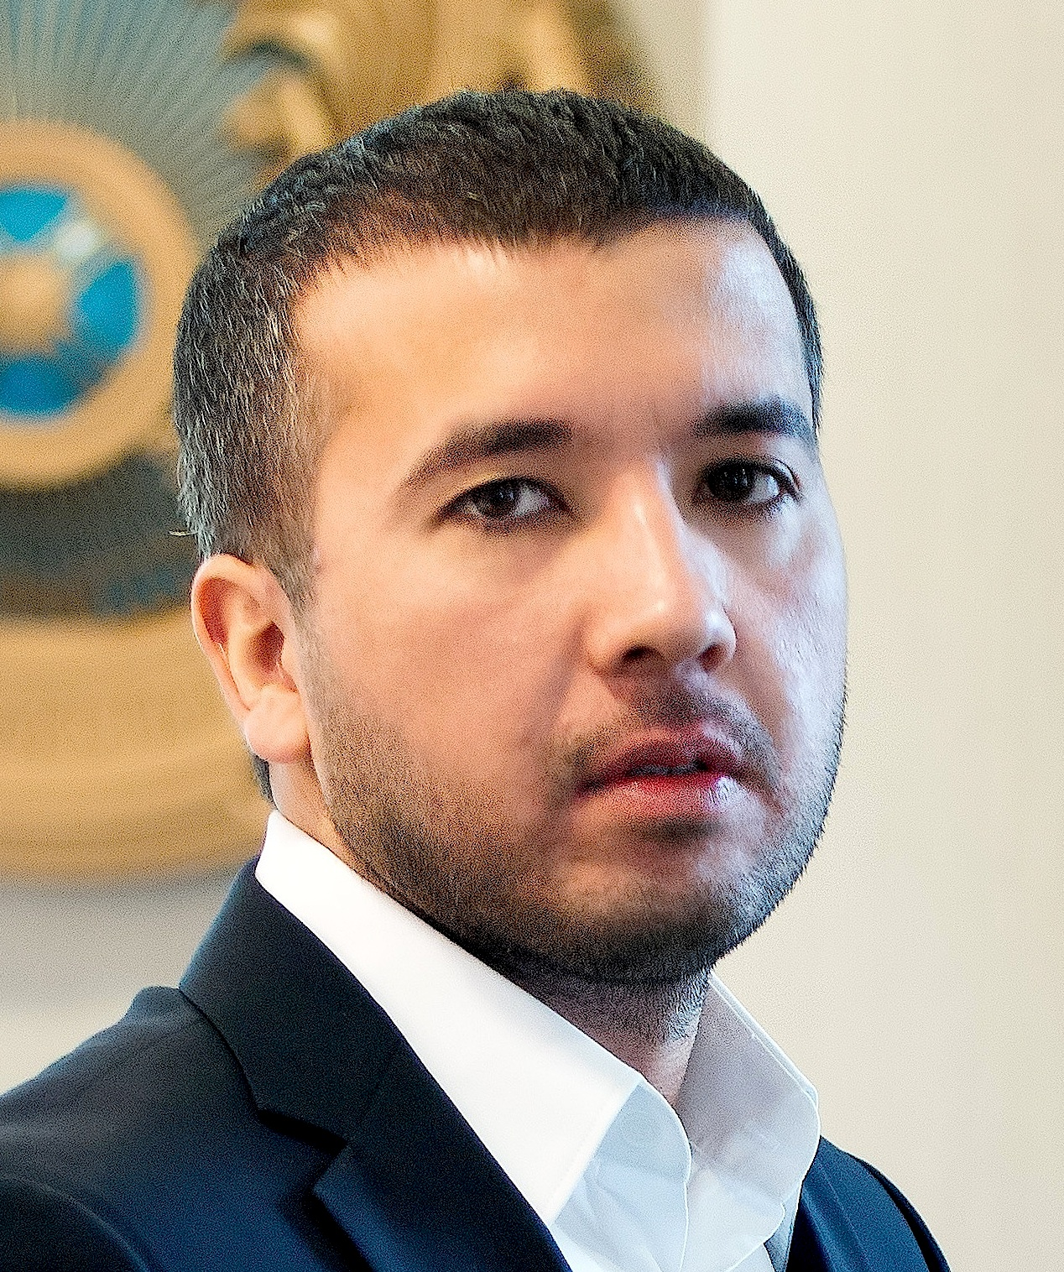
Mr. Umit Khairollayev (Kazakhstan), 31, is Chief Executive Officer at the Carlyle Group in Kazakhstan. The Carlyle Group supplies the markets in Central Asia, the Caucasus, Turkey and Mongolia with air freshening, water purifying, and health care products. In his capacity of CEO, Mr. Khairollayev manages and coordinates projects that work to solve ecological and environmental problems in the abovementioned regions. Under his leadership, over 140 environmental projects have been designed and successfully launched to improve the quality of life and the management of resources in the region. From 2008 to 2011 Mr. Khairollayev was the President of ElitEcoGarant Corporation where he built and implemented a complete distribution strategy for the Aquapick, PurePro, Lange, and Water Therapy brands in the region engaging both the B2B industrial sector and consumer channels. He introduced modern manufacturing techniques and adapted solutions to specific requirements and environments that resulted in 20% cost reduction and a 30% decrease in manufacturing cycle time. In the time of his leadership the company also achieved 86% of market coverage. Mr. Khairollayev holds a B.A. in Chemistry from Lomonosov Moscow State University (2004). Research project: "The Eurasian Economic Union: Economic and Political Outlook."

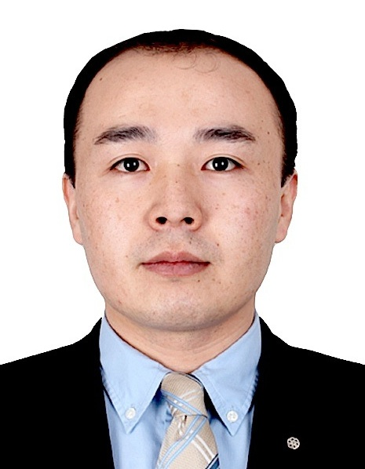
Mr. Daniel Kadyrbekov (Kyrgyz Republic), 29, is an Aide to the Prime Minister of the Kyrgyz Republic on economic reforms and investments. His responsibilities include coordinating the work of the Government Ministries and other state institutions in the areas of economic reforms, improvement of the business environment and attracting Foreign Direct Investments (FDI). Currently he focuses on developing and implementing reforms in the area of the state asset management. Prior to joining the Prime Minister’s office, Mr. Kadyrbekov worked as an Aide to the First Deputy Prime Minister on economics and investments, and as a Senior Expert in the Department of FDI, Foreign Aid and Public-Private Partnership at the Ministry of Economy of the Kyrgyz Republic. Mr. Kadyrbekov holds a B.A. in Finance and Taxation from the Department of Economics of Osh Trade College (2003), a Certificate in Political Science from Berea College, Kentucky (2007), a Diploma in International Relations (B.A. equivalent) from Osh Technological University (2008), and a M.A. in Political Science from the Graduate School of International Cooperation Studies, Kobe University, Japan (2011). Research project: "Community Based Tourism Enterprises: Benefits and Challenges."

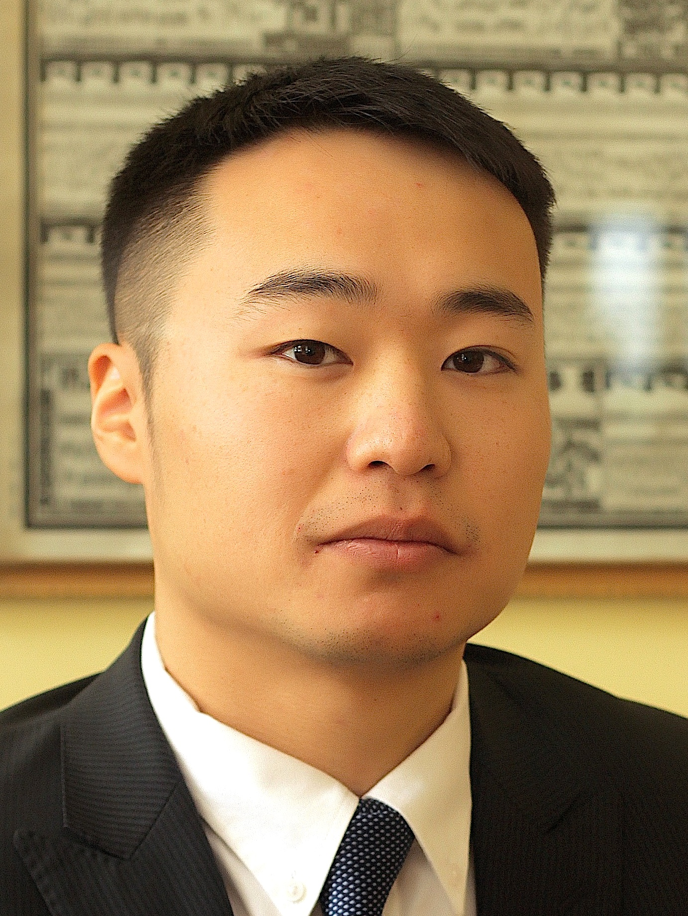
Mr. Badruun Gardi (Mongolia), 28, is the founder and CEO of Ger Hub and a civil society leader in Mongolia with a deep interest in issues of national development. Ger Hub is a nonprofit social enterprise that aims to develop uncommon solutions to common problems in Ulaanbaatar, the capital city of Mongolia. By creating opportunities for interdisciplinary collaboration, Ger Hub seeks to transform the living environments of the urban poor. From 2011 to 2014, Mr. Gardi served as Executive Director of the Zorig Foundation, a leading non-governmental organization in Mongolia that focuses on three main areas: good governance, youth and education, and community development. Mr. Gardi has previously been an adjunct fellow at the Urban Communities Research Center for Asia at the Kwansei Gakuin University in Sanda, Japan. Mr. Gardi also serves on the boards of the Institute of Engineering and Technology, Mongolian Association of State Alumni, and AIESEC Mongolia. He is an alumnus of the U.S. Department of State’s International Visitor Leadership Program and the inaugural class of the Asia Foundation Development Fellowship. Mr. Gardi is a frequent guest at conferences and events where he talks about civil society and civic engagement. Mr. Gardi holds a B.A. with a double major in Psychology and Communication from Stanford University (2009). Research Topic: "Effective Methods for Policy Advocacy."

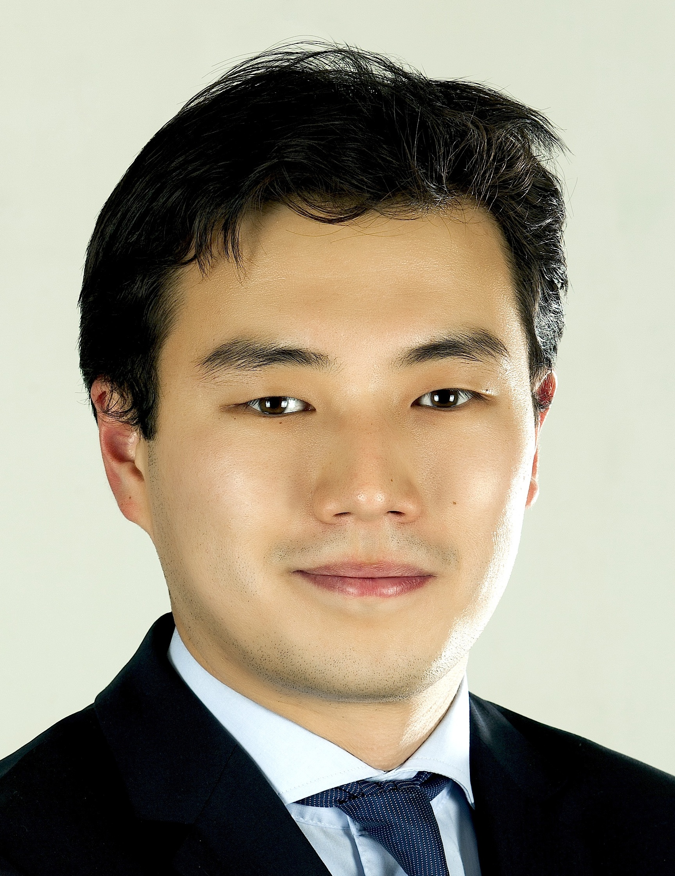
Mr. Tuvshinzaya Gantulga (Mongolia), 27, is the Executive Director of the American Chamber of Commerce (AmCham) in Mongolia. He is in charge of management, public and media relations, and most importantly advocacy activities for AmCham Mongolia. Mr. Tuvshinzaya has successfully positioned AmCham Mongolia as one of the most influential business associations in the country. He also led the first-ever Mongolian trade mission to the U.S. Prior to joining AmCham, Mr. Tuvshinzaya worked for the Zorig Foundation, one of the most prominent NGOs in Mongolia, where he coordinated public policy, education, and community development projects. Forbes Mongolia recently named Mr. Tuvshinzaya on their 30 under 30 list of the most influential change-makers in the country. Mr. Tuvshinzaya holds a B.A. in Value Studies with a concentration in Political Philosophy and Literature from Bard College in Berlin, Germany (2012) and studied Political Science and Economics at Franklin and Marshall College in Lancaster. Pennsylvania. He was also a Stanford University’s Summer Fellow at the Center on Democracy, Development, and the Rule of Law in Ulaanbaatar, Mongolia (2014). While at college, Mr. Tuvshinzaya rowed for varsity crew, and later represented Mongolia at the 2013 Head of the Charles Regatta in Boston. Research project: "U.S.-Mongolia Free Trade Agreement: Empty Dream or Real Possibility?"

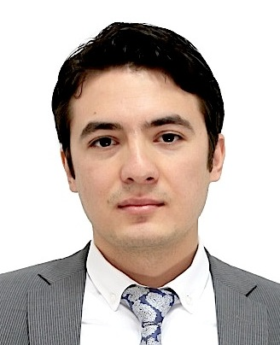
Mr. Abdullo Kurbanov (Tajikistan), 29, is Co-founder and CEO of Alif Capital, a microcredit organization based in Tajikistan. Previously he served as Deputy Chairman of the Board of Orienbank, one of the largest commercial banks in Tajikistan. Prior to joining Orienbank in July 2012, Mr. Kurbanov was Vice-President for Mining Investments at Origo Partners PLC, a London Stock Exchange listed private equity company with investments primarily in Mongolia and China. While at Origo Partners Mr. Kurbanov was based in Ulaanbaatar and was in charge of Mongolia investments, managing the portfolio of existing assets (copper, coal, moly projects) and originating new deals. Earlier, Mr. Kurbanov was based in London working as an analyst in the Metals & Mining team of UBS Investment Bank, a Swiss global investment bank. He also worked for Oliver Wyman (Financial Consulting) out of London and Moscow, where he advised clients on risk management, particularly, modeling credit risk. Mr. Kurbanov holds a B.A. in Management from Bogazici University in Istanbul, Turkey (2008) and a M.Sc. in Finance from the London School of Economics, UK (2009). Research Project: "Application of Mobile Distribution Technologies and Crowd-funding for Microfinance in Tajikistan."

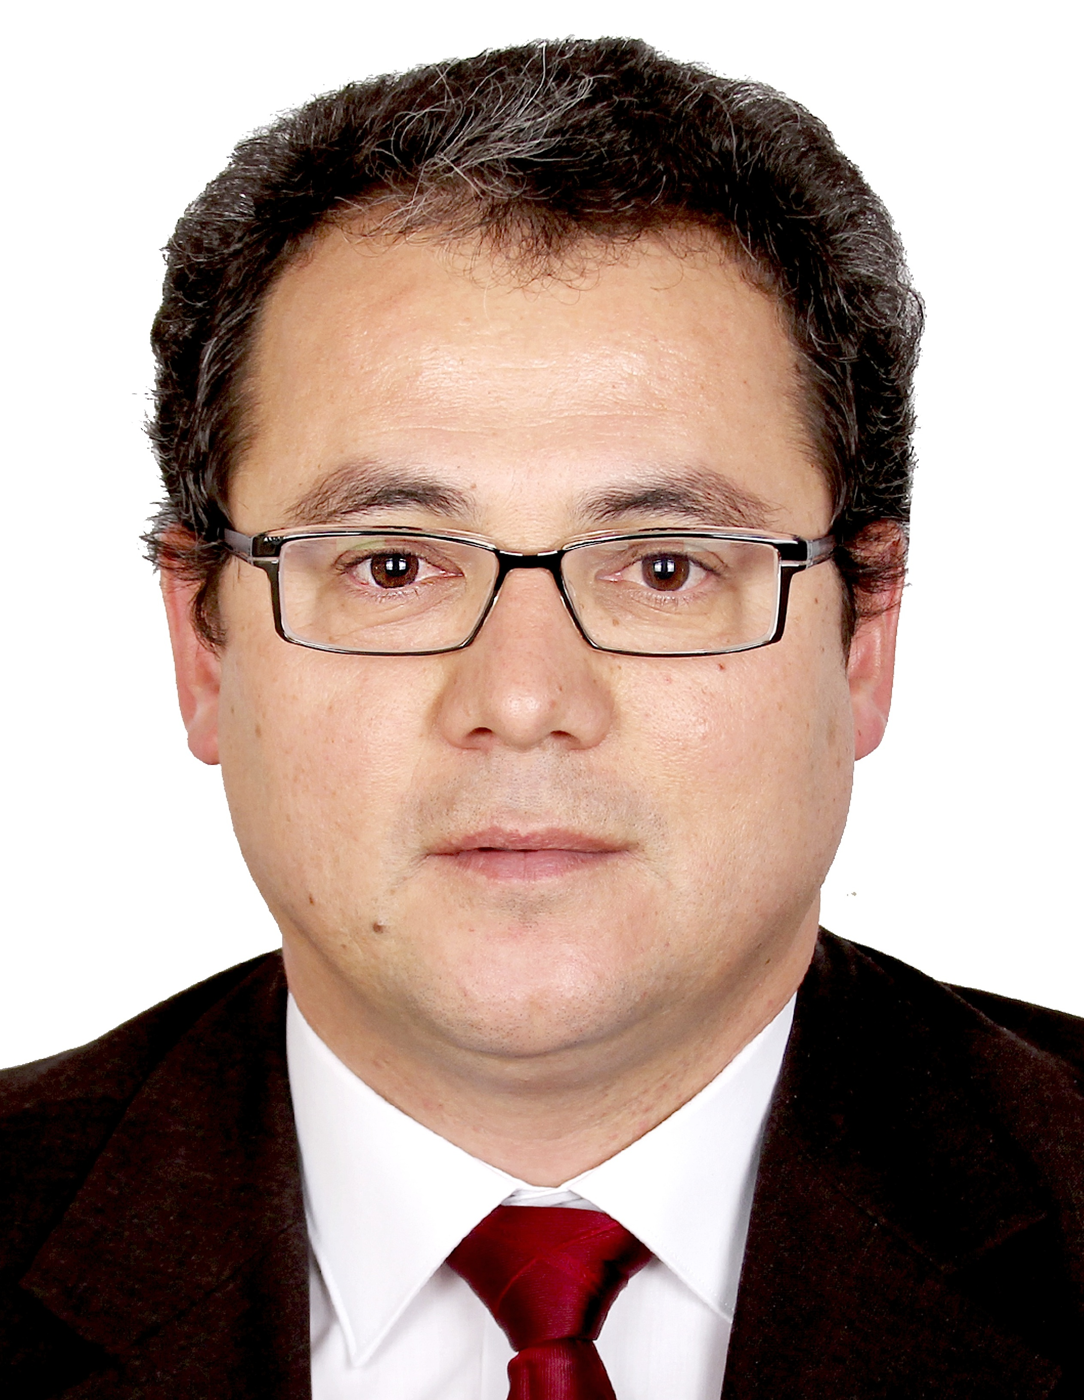
Mr. Mirzokhid Rakhimov (Uzbekistan), 40, is Head of the Department of Contemporary History and International Relations in the Institute of History of the Academy of Sciences of Uzbekistan and a Professor at the University of World Economy and Diplomacy in Tashkent. His academic interests include contemporary history and politics in Central Asia, and international and regional relations in Central Asia. Mr. Rakhimov has conducted research on these topics at the University of Washington, Seattle (2003), the University of Georgia, Athens, GA (2004), Leiden University, Netherlands (2005), University of Cambridge, UK (2006), NATO Defense College in Rome, Italy (2006), The School of Oriental and African Studies (SOAS), University of London (2007), University of Giessen, Germany (2009), Slavic-Eurasian Research Center at Hokkaido University, Japan (2010), and the University of Bielefeld, Germany (2011, 2012). He is an author and an editor of several books as well as multiple articles and chapters, and is a frequent speaker at international conferences, seminars and workshops. Mr. Rakhimov holds a M.A. in History from Navoi State Pedagogical Institute (1996) and a Ph.D. in History (2001) from the Institute of History of the Academy of Sciences of Uzbekistan. Research project: "U.S.-Uzbek Relations and Their Prospects in the Context of Stability and Connectivity of Central Asia."

